

DAA WEEK – 9 SKILL – 9



# [Cloudy Day](https://www.hackerrank.com/contests/daa-skill-09-greedy-method-part-ii/challenges/cloudy-day) ( JAVA 7 )

import java.io.*;

import java.util.*;

public class CloudyDay {

static int ni(InputStream is) throws IOException {

int num = 0, b;

boolean minus = false;

while ((b = is.read()) != -1 && !((b >= '0' && b <= '9') || b == '-')) ;

if (b == '-') {

minus = true;

b = is.read();

}

while (b >= '0' && b <= '9') {

num = num * 10 + (b - '0');

b = is.read();

}

return minus ? -num : num;

}

public static void main(String[] args) throws IOException {

InputStream is = System.in;

PrintWriter out = new PrintWriter(System.out);

int n = ni(is);

int[][] pt = new int[n][2];

for (int i = 0; i < n; i++) pt[i][0] = ni(is);

for (int i = 0; i < n; i++) pt[i][1] = ni(is);

Arrays.sort(pt, new Comparator<int[]>() {

@Override

public int compare(int[] a, int[] b) {

return Integer.compare(a[1], b[1]);

}

});

int m = ni(is);

int[][] cs = new int[m][2];

for (int i = 0; i < m; i++) cs[i][0] = ni(is);

for (int i = 0; i < m; i++) cs[i][1] = ni(is);

for (int i = 0; i < m; i++) {

int l = cs[i][0] - cs[i][1];

int r = cs[i][0] + cs[i][1];

cs[i][0] = l;

cs[i][1] = r;

}

int[] ts = new int[n];

for (int i = 0; i < n; i++) ts[i] = pt[i][1];

long[] imos = new long[n + 2];

for (int i = 0; i < m; i++) {

int l = Arrays.binarySearch(ts, cs[i][0]);

if (l < 0) l = -l - 1;

int r = Arrays.binarySearch(ts, cs[i][1]);

if (r < 0) r = -r - 2;

imos[l]++;

imos[r + 1]--;

}

for (int i = 0; i < n; i++) imos[i + 1] += imos[i];

long base = 0;

for (int i = 0; i < n; i++) {

if (imos[i] != 1) {

if (imos[i] == 0) base += pt[i][0];

imos[i] = 0;

} else {

imos[i] = pt[i][0];

}

}

for (int i = 0; i < n; i++) imos[i + 1] += imos[i];

long ans = 0;

for (int i = 0; i < m; i++) {

int l = Arrays.binarySearch(ts, cs[i][0]);

if (l < 0) l = -l - 1;

int r = Arrays.binarySearch(ts, cs[i][1]);

if (r < 0) r = -r - 2;

ans = Math.max(ans, (r < 0 ? 0 : imos[r]) - (l - 1 < 0 ? 0 : imos[l - 1]));

}

out.println(base + ans);

out.flush();

}

}

**Cloudy Day Test Cases**

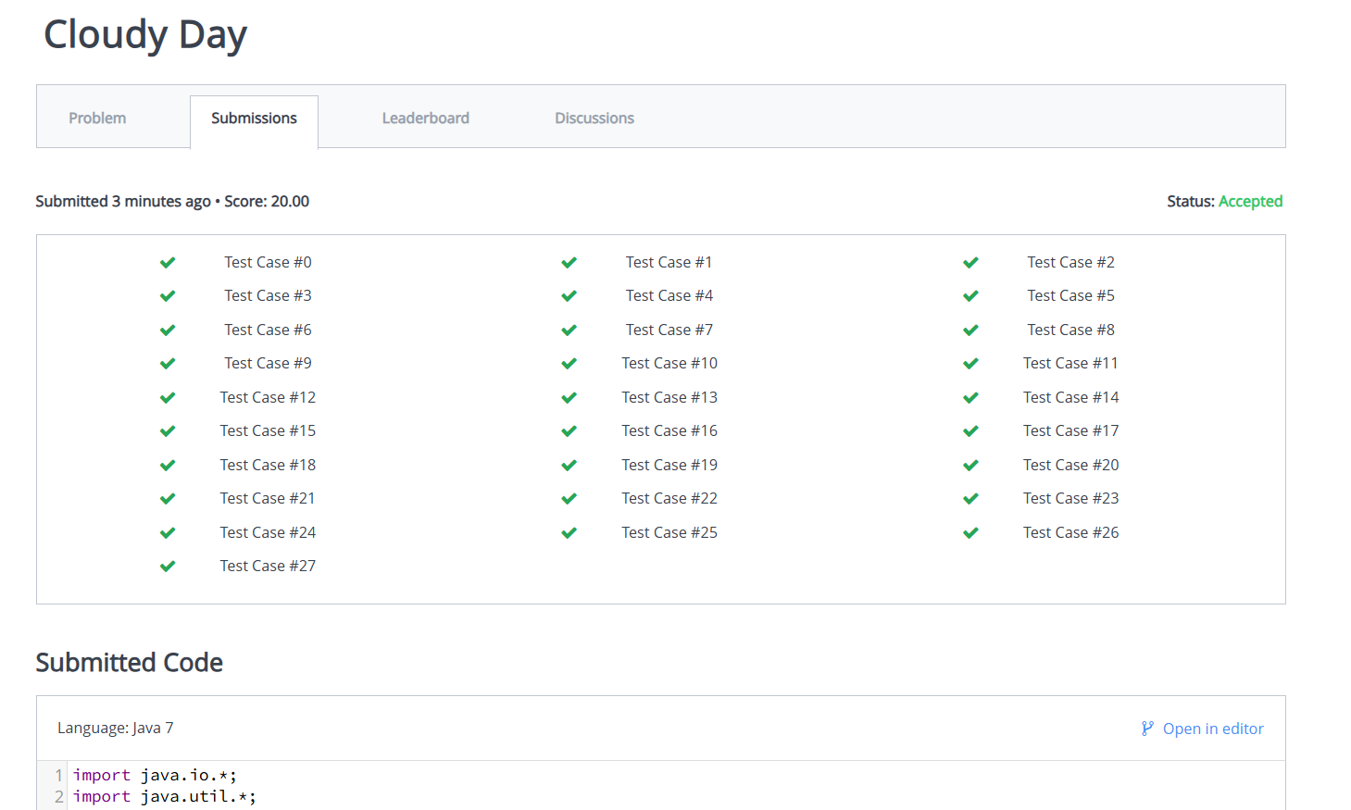

# [Accessory Collection](https://www.hackerrank.com/contests/daa-skill-09-greedy-method-part-ii/challenges/accessory-collection)

#include <stdio.h>

#include <stdlib.h>

#define REP1(i, n) for (i = 1; i <= (n); i++)

int main() {

long cc, l, a, n, d;

scanf("%ld", &cc);

while (cc--) {

scanf("%ld %ld %ld %ld", &l, &a, &n, &d);

if (d > a)

printf("SAD\n");

else if (d == 1)

printf("%ld\n", l * a);

else {

long s = -1, i;

REP1(i, (n - 1) / (d - 1)) {

long x = n - 1 - (d - 1) * i;

if (x + a * i < l) continue;

long c = (l - x) / i;

s = s > (a * x + (2 * a - c + 1) * c / 2 * i + (a - c) * ((l - x) % i)) ? s : (a * x + (2 * a - c + 1) * c / 2 * i + (a - c) * ((l - x) % i));

}

if (s < 0)

printf("SAD\n");

else

printf("%ld\n", s);

}

}

return 0;

}

**Accessory Collection Test Cases**

**SKILL WEEK – 9**

[**https://www.hackerrank.com/contests/daa-skill-09-greedy-method-part-ii/challenges**](https://www.hackerrank.com/contests/daa-skill-09-greedy-method-part-ii/challenges)